Software Requirement Specifications
AI-enhanced E-commerce Platform Using WooCommerce



Submitted by
Ammaz Jamil (F22BINFT1M01284)
Fatima Tuz Zahra (F22BINFT1M01283)

Submitted to
Sir Faisal Shahzad

Department of Information Technology
Faculty of Computing
The Islamia University of Bahawalpur
Meeting Details
Sr No | Details | Date | Supervisor Signature
1 | Approval Of Project Proposal Idea. | 17-11-2025
2 | We had a detailed discussion on the SRS with our supervisor. | 3-12-2025
3 | We presented the SRS to our supervisor, who reviewed and approved it. | 4-12-2025

Summary

This project aims to develop an AI-enhanced, multi-vendor e-commerce platform using WordPress and WooCommerce, tailored for the Pakistani online market. The system provides customers with a seamless shopping experience through features like product browsing, secure checkout, local payment gateway integration, and AI-based product recommendations. Vendors can register, manage products and receive automated commission calculations, while administrators oversee the entire system through a centralized dashboard. The platform includes an AI-powered chatbot for user assistance, social media sharing with rewards, and personalized customer dashboards. Built with PHP, MySQL, and pre-built AI tools, the website emphasizes security, scalability, responsive design, and smooth integration with services like JazzCash, Easypaisa, and social media platforms.

Table of Contents

1. Introduction 5
1.1. Purpose 5
1.2. Scope 6
1.3. Product Perspective 6
1.4. User Characteristics 7
1.5. Similar apps and systems/Literature Review 7
1.6. Proposed Technologies 8
2. Requirements 8
2.1. Function Requirements 9
2.1.1 User Registration 9
2.2. Non-Functional Requirements 15
3. Use Cases and Flow of Processes 16
3.1. Use Case 1: User Registration 17
3.2. Use Case 2: User Login 19
3.3. Use Case 3: Browse Product Catalog 21
3.4. Use Case 4: Product Details View 23
3.5. Use Case 5: Order Placement and Checkout 25
3.6. Use Case 6: Personalized Customer Dashboard 27
3.7. Use Case 7: AI-Powered Product Recommendations 29
3.8. Use Case 8: AI-Powered Chatbot Assistance 31
3.9. Use Case 9: Admin Panel 33
4. References 35

- Introduction
This project involves the development of an AI-Driven and feature-rich e-commerce website tailored for the growing online retail market in Pakistan. The platform will be built using WooCommerce on WordPress, focusing on enhancing user experience through personalized engagement tools. The website will serve as a demonstrative model of a modern e-commerce solution capable of handling multiple vendors, AI-driven recommendations, and seamless customer interactions.

The core modules to be developed include:
- WooCommerce-based store with product catalog, cart, and checkout
- AI-powered product recommendation system
- Personalized customer dashboard
- Multi-vendor management system
- Social media integration for sharing and rewards
- Chatbot Integration

  - Purpose
The purpose of this project is to design, develop, and deploy a fully functional e-commerce platform using WooCommerce that:
- Provides a user-friendly online shopping experience.
- Implements AI-driven personalization to increase engagement and sales.
- Supports multiple vendors to create a marketplace environment.
- Ensures scalability, security, and maintainability.

  - Scope
In Scope:
- Development of a responsive e-commerce website using WordPress and WooCommerce.
- Integration of an AI-based product recommendation model.
- Design and implementation of a personalized user dashboard.
- Social media sharing functionality with reward mechanisms.
- Multi-vendor support with commission-based payment tracking.
- Front-end development using HTML/CSS, JavaScript, and WordPress themes.
- Back-end development using PHP, WooCommerce hooks, and custom plugins.
- MySQL database design and integration.
- Comprehensive documentation (technical and user manuals).

Out of Scope:
- Provision of hosting services or server setup (though requirements will be specified).
- Development of custom payment gateways (integration only with existing ones like JazzCash, Easypaisa, Cash on Delivery).
- Mobile application development (website will be responsive).
- Advanced AI model training from scratch (pre-built models/plugins will be utilized).

  - Product Perspective
This e-commerce platform will function as a standalone web application. It will integrate with:
- WordPress CMS as the foundation.
- WooCommerce as the e-commerce engine.
- External APIs for payment gateways and shipping carriers.
- Pre-built AI/ML models or plugins for recommendation features.
- Social media platforms (Facebook, Twitter, Instagram) for sharing.
- AI-Powered Chatbot System for automated customer support, FAQs, product assistance, and real-time user engagement

The system will be modular, allowing future expansion such as adding new payment methods, vendor features, or analytics dashboards.
  - User Characteristics
1. Customer: Browses products, makes purchases, views AI recommendations, uses dashboard, shares products on social media.
- Vendor: Sells products, manages inventory and receives commission-based payments.
- Administrator: Manages website content, users, vendors, products, orders, system settings, and monitors performance.
- Guest User: Can browse products but must register to make purchases or access personalized features

  - Similar apps and systems/Literature Review
Existing e-commerce platforms in Pakistan and globally include:
- Daraz.pk
- Strengths: Supports many vendors, gives recommendations, and allows order tracking.
- Weakness: Vendor onboarding is complicated and personalization options are limited.
- Shopify
- Strengths: Easy to set up and has many plugins for recommendations.
- Weakness: Monthly fees are high and customization is limited.
- Amazon
- Strengths: Very strong AI recommendations and real-time tracking.
- Weakness: Not designed for Pakistani sellers or local payment options.
- WooCommerce Stores
- Strengths: Highly customizable and open-source.
- Weakness: Lacks built-in AI features and needs extra plugins.

This project aims to create a WooCommerce-based platform that adds AI-powered personalization and multi-vendor support, specifically designed for Pakistani users and payment methods.

  - Proposed Technologies
- Front-end: HTML5, CSS3, JavaScript, WordPress Theme
- Back-end: PHP, WordPress REST API, WooCommerce, Custom Plugin Development
- Database: MySQL
- AI/ML Component: Pre-built recommendation plugins, TensorFlow.js, or custom AI API integration
- Payment Gateways: JazzCash, Easypaisa, Stripe (via WooCommerce plugins)
- Chatbot Integration: AI-powered chatbot using WordPress chatbot plugins or OpenAI Assistants/API for automated customer support
- Version Control: GitHub

- Requirements
The e-commerce platform will allow customers to browse and purchase products from multiple vendors. Users will register, log in, and manage their profiles. The system will feature a product catalog with search and category filtering, a shopping cart, AI-Powered chatbot and a secure checkout process integrating local payment gateways. A personalized customer dashboard will display order history, and AI-generated product recommendations. Vendors will have dedicated interfaces to manage their product listings, inventory, and view sales reports. Administrators will oversee the entire platform, managing users, vendors, products, orders, and system settings. Unique features include a social sharing and rewards system and a multi-vendor commission management system.

  - Function Requirements (FRs)

2.1.1 User Registration
- Name: FR001
- Purpose: To allow a new user (Customer/Vendor) to create an account and become a member of the platform.
- User(s): Customer, Vendor
- Input:
- Full Name: As per user's identity.
- Email Address: A valid and unique email for communication.
- Password: Must be at least 8 characters long, containing one uppercase letter, one lowercase letter, and one number.
- Phone Number: A valid Pakistani mobile number (format: +92XXXXXXXXXX).
- User Type: Selection between 'Customer' and 'Vendor'.
- (For Vendors) Business Name
- Output: A new user account is created. A verification email is sent. The user can log in after email confirmation.

2.1.2. User Login
- Name: FR002
- Purpose: To authenticate registered users and grant access to the platform based on their role.
- User(s): Customer, Vendor, Administrator
- Input:
- Email Address / Username
- Password
- Output: Successful authentication grants access to the user's respective dashboard (Customer, Vendor, or Admin). Failed authentication returns an error message.

2.1.3. Browse Product Catalog
- Name: FR003
- Purpose: To allow users (Customers, Guests) to view all available products.
- User(s): Customer, Guest
- Input:
- Navigation via categories/subcategories.
- Search keywords (via search bar).
- Filtering by price range, brand, vendor, ratings.
- Sorting by price (low-high, high-low), popularity, new arrivals.
- Output: A paginated, responsive grid/list of products with images, titles, prices, and vendor names.

2.1.4. Product Details View
- Name: FR004
- Purpose: To display comprehensive information about a single product.
- User(s): Customer, Guest
- Input: Clicking on a product from the catalog.
- Output: A dedicated page displaying product images, title, detailed description, price, available stock, vendor info, customer reviews/ratings, and related product recommendations.

2.1.5. Shopping Cart Management
- Name: FR005
- Purpose: To allow customers to add, update, or remove products before checkout.
- User(s): Customer
- Input:
- Add to Cart: Product ID, selected quantity.
- Update Cart: Cart item ID, new quantity.
- Remove Item: Cart item ID.
- Output: A persistent cart showing product summary, quantities, subtotals, and a calculated total. Cart contents are saved per user session/account.

2.1.6. Order Placement & Checkout
- Name: FR006
- Purpose: To finalize the purchase by collecting shipping/payment details and creating an order.
- User(s): Customer (Logged-in), Payment Gateway
- Input:
- Shipping Address.
- Contact Information.
- Selected Shipping Method.
- Selected Payment Gateway (JazzCash, Easypaisa).
- Confirmation of Terms & Conditions.
- Output: An order is created with a unique Order ID. The customer is redirected to the chosen payment gateway. Upon successful payment, order status is updated to 'Processing'.

2.1.7. Multi-Vendor Order Splitting & Settlement
- Name: FR007
- Purpose: To ensure orders containing products from multiple vendors are automatically split and processed individually.
- User(s): Customer, Vendor, Administrator
- Input:
- Customer checkout with multiple vendor products
- Shipping method selection per vendor (if applicable)
- Output:
- A parent order is created and split into sub-orders per vendor.
- Vendors receive their respective order notifications.
- Admin panel displays settlement details per order.
- Commission and vendor earnings are automatically calculated per sub-order.

2.1.8. Personalized Customer Dashboard
- Name: FR008
- Purpose: To provide customers a central hub for managing their account and viewing personalized data.
- User(s): Customer
- Input: User login (FR002).
- Output: Dashboard displays: (a) Order history with statuses, (b) AI-generated product recommendations, (c) Account details (editable), (d) Wishlist, (e) Reward points balance.

2.1.9. AI-Powered Product Recommendations
- Name: FR009
- Purpose: To increase engagement and sales by suggesting relevant products to users.
- User(s): Customer
- Input: User's browsing history, purchase history, items in cart, and demographic data (implicitly collected).
- Output: A dynamically generated section on the homepage, product pages, and dashboard displaying recommended products.

2.1.10. AI-Powered Chatbot Assistance
- Name: FR010
- Purpose: To provide users with real-time support, guidance, and personalized assistance across the platform.
- User(s): Customer, Vendor
- Input: User queries entered via the chatbot interface (e.g., questions about products, cart, orders, account management, or site navigation).
- Output: Contextual responses, step-by-step guidance and product suggestions.

2.1.11. Social Media Sharing & Rewards
- Name: FR011
- Purpose: To encourage marketing via social shares and reward users for it.
- User(s): Customer
- Input: Customer clicks a "Share on Facebook/Twitter/Instagram" button on a product page.
- Output: A pre-populated post with product link is opened on the selected social platform. Upon successful share verification and reward points are credited to the user's account.

2.1.12. Vendor Ratings & Reviews
- Name: FR012
- Purpose: To allow customers to rate and review vendors based on product quality, service, and delivery.
- User(s): Customer, Vendor, Guest (read-only)
- Input:
- Rating score (1–5 stars)
- Order ID verification (review allowed only after purchase)
- Output:
- Vendor profile displays average rating and customer reviews.
- Reviews appear publicly on vendor pages.
2.1.13. Vendor Product Management
- Name: FR013
- Purpose: To allow vendors to add, edit, or deactivate their products.
- User(s): Vendor
- Input:
- Product details (title, description, images, category, price, stock quantity, attributes).
- Edit/Update actions on existing products.
- Status toggle (Active/Inactive).
- Output:
- Products are added/updated in the public catalog.
- Vendor sees a list of their managed products with status indicators.

2.1.14. Admin Multi-Vendor & Commission Management
- Name: FR014
- Purpose: To allow the administrator to manage vendors and configure commission settings.
- User(s): Administrator
- Input:
- Approve/Reject new vendor registrations.
- Set global or per-vendor commission rates (percentage of sale).
- View reports of commissions due per vendor per period.
- Output:
- Vendor status updates.
- Commission reports are generated.
- System automatically calculates commission on each order.

2.1.15. Admin Panel
- Name: FR015
- Purpose: To allow the administrator to manage the entire system from a centralized interface.
- User(s): Administrator
- Input:
- Admin login
- Actions such as adding, editing, or removing users, vendors, products, or orders Settings updates
- Output:
- Updated system data
- Dashboard showing system statistics
- Success or error messages confirming admin actions performed

  - Non-Functional Requirements (NFRs)
  - Performance:
- The homepage and product pages should load within 3 seconds.
- The system should support up to 100 users at the same time without issues.
- Product search results should appear within 2 seconds.

  - Usability:
- The website must be responsive and work properly on all modern browsers and mobile devices.
- A new user should be able to complete the checkout in 5 steps or less (Cart, Login/Guest Checkout, Shipping Details, Payment Details and Order Confirmation)

- Security:
- All user passwords must be securely hashed using bcrypt.
- The system must use official secure payment APIs and must not store any credit card details on platform’s server.
- Role-based access control (RBAC) must be used to protect Admin and Vendor dashboards from unauthorized access.

- Scalability & Maintainability:
- WooCommerce and plugins should be easy to update without breaking the system.
- Code should be well-documented and follow WordPress/PHP coding standards.

- Compatibility:
- The system must properly integrate with the specified third-party services: JazzCash API, Easypaisa API.

- Use Cases and Flow of Processes

Use cases describe how different actors (Customer, Vendor, Admin, Guest) interact with the system. These use cases are derived directly from the Functional Requirements. A system-level use case diagram must show all actors and their interactions with the proposed E-commerce platform.
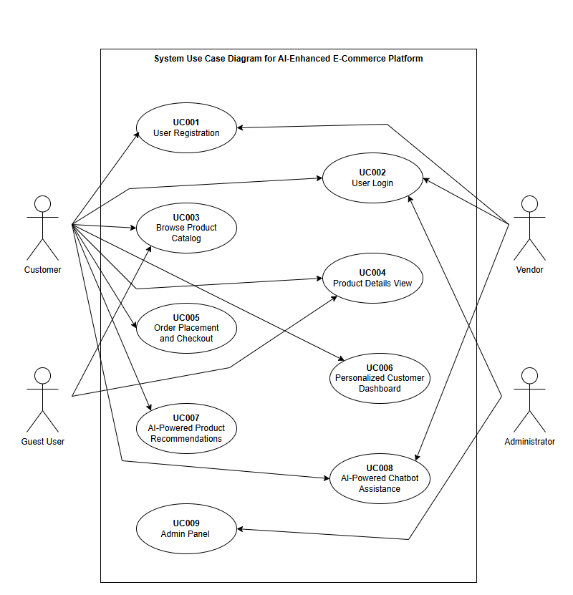

  - Use Case 1: User Registration
ID | UC001
Name | User Registration
Description | Allows a new Customer or Vendor to create an account.
Requirement(s) | FR001
Actor(s) | Customer, Vendor
Precondition | User does not have an existing account.
Postcondition | User account is created and email verification is sent.
Basic Flow | Basic Flow  - User opens the Sign Up page  - User enters details  - Following fields are required  - Name  - Email  - Password  - Address  - Phone  - Check the proper inputs for following  - Email is Valid  - Password must be strong  - Phone Number format is correct  - On successful validation the system will create new user  Alternative Flow  - Registration with missing optional fields.  - Resend verification email if user does not receive it.  Exceptions  - Invalid inputs or duplicate email.  - Password not meeting criteria.  - System unable to response.

UML Activity Diagram:

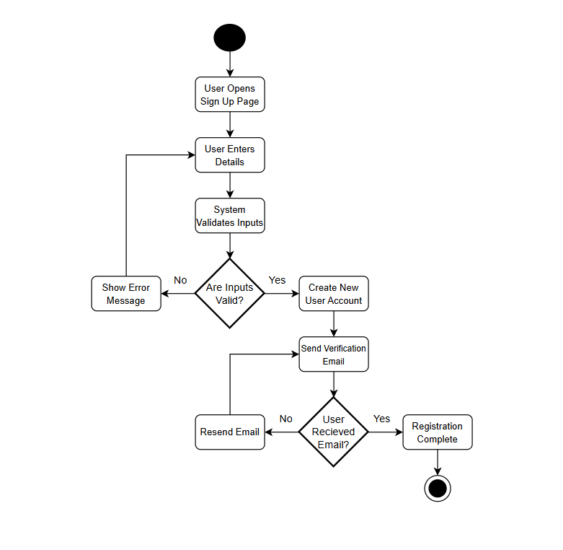
  - Use Case 2: User Login

ID | UC002
Name | User Login
Description | Authenticates registered users and grant access based on their role.
Requirement(s) | FR002
Actor(s) | Customer, Vendor, Administrator
Precondition | User must have a verified account.
Postcondition | User is logged in and redirected to their respective dashboard.
Basic Flow | Basic Flow  - User navigates to login page.  - User enters email/username and password.  - System validates credentials.  - Upon successful authentication, user is redirected to their dashboard (Customer, Vendor, Admin).  Alternative Flow:  - User resets password if forgotten.  Exceptions:  - Invalid credentials.  - Account not verified.

UML Activity Diagram:

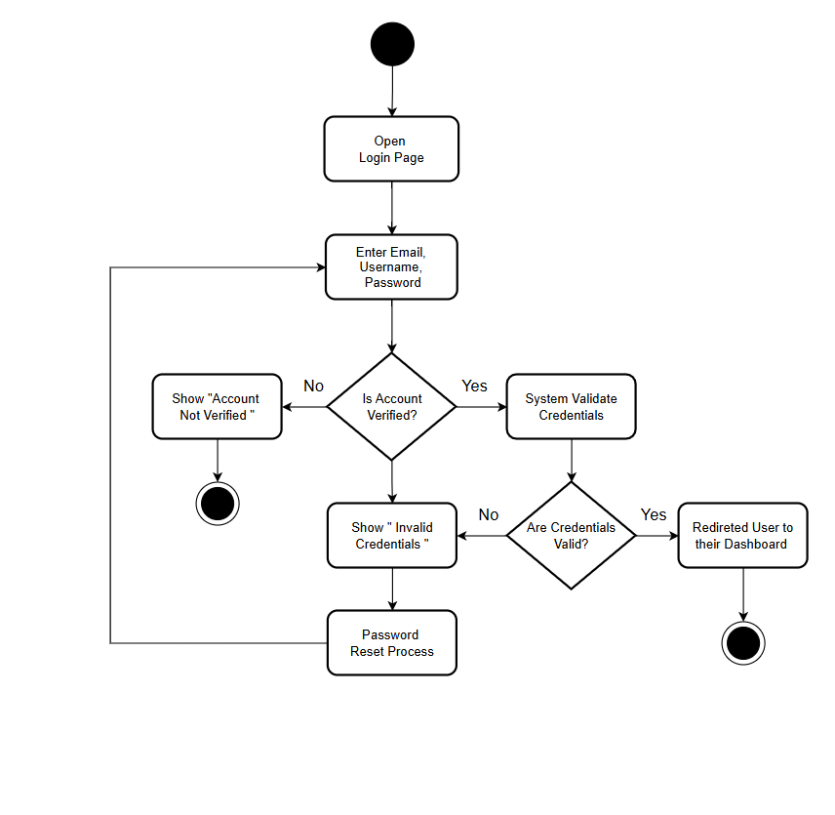

  - Use Case 3: Browse Product Catalog

ID | UC003
Name | Browse Product Catalog
Description | Allows users (Customers, Guests) to view all available products using categories, search and filters.
Requirement(s) | FR003
Actor(s) | Customer, Guest
Precondition | Products exist in catalog.
Postcondition | Products are displayed based on search, filter, or category selection.
Basic Flow | Basic Flow  - User navigates to the product catalog.  - User applies category filters, search keywords, price range, vendor, or rating filters.  - System displays products in a paginated grid/list format with images, names, prices, and vendor names.  Alternative Flow:  - User sorts products by popularity, price, or new arrivals.  Exceptions:  - No products found for search/filter criteria.  - Server or database error.

UML Activity Diagram:

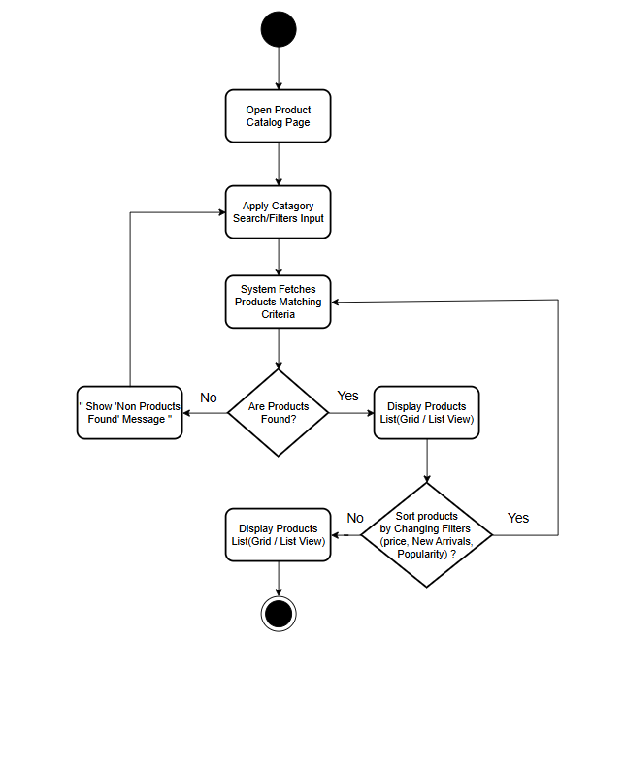

  - Use Case 4: Product Details View

ID | UC004
Name | Product Details View
Description | Displays detailed information for a selected product.
Requirement(s) | FR004, FR009
Actor(s) | Customer, Guest
Precondition | Product exists in catalog.
Postcondition | Detailed product page is displayed.
Basic Flow | Basic Flow  - User clicks on a product.  - System displays product images, title, description, price, stock availability, vendor info, reviews, and related products.  Alternative Flow:  - User adds product to Wishlist or cart from this page.  Exceptions:  - Product no longer available or out of stock.

UML Activity Diagram:

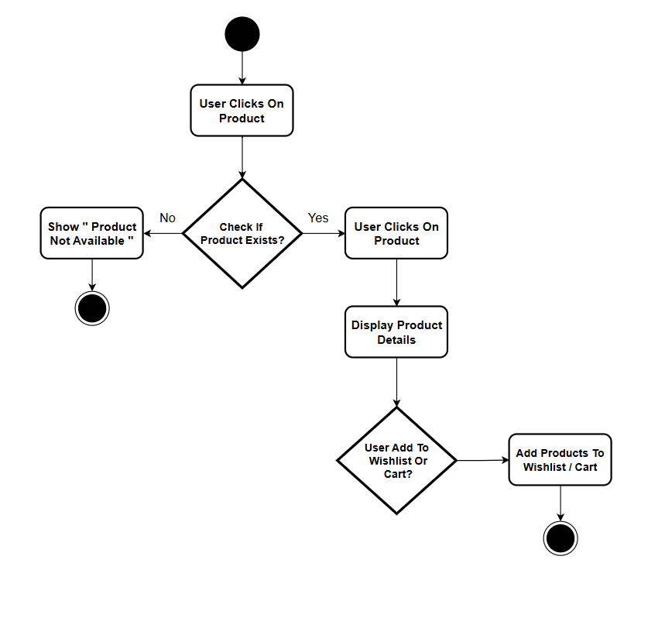

  - Use Case 5: Order Placement and Checkout

ID | UC005
Name | Order Placement and Checkout
Description | Customer finalizes order by providing shipping and payment information.
Requirement(s) | FR005, FR006, FR007
Actor(s) | Customer
Precondition | User must be logged in and have items in the cart.
Postcondition | Order is created with a unique ID; payment is processed; status updated.
Basic Flow | Basic Flow  - User navigates to the cart.  - User clicks “Checkout.”  - User provides shipping address, contact info, selects shipping method and payment gateway.  - User confirms terms and conditions.  - System processes payment and creates the order.  - Order status updated to ‘Processing.’  Alternative Flow:  - User selects cash on delivery as payment option.  Exceptions:  - Payment failure.  - Invalid shipping details.

UML Activity Diagram:
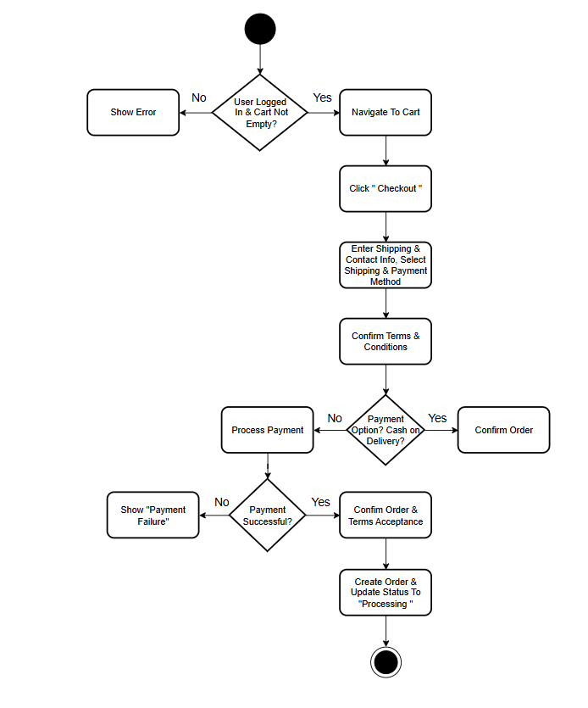
  - Use Case 6: Personalized Customer Dashboard

ID | UC006
Name | Personalized Customer Dashboard
Description | Provides a hub for users to manage account details, view orders, and get personalized recommendations
Requirement(s) | FR008, FR009, FR011
Actor(s) | Customer
Precondition | User must be logged in
Postcondition | Dashboard displays account info, order history, wishlist, rewards, and AI recommendations
Basic Flow | Basic Flow  - User logs in.  - System displays dashboard with order history, AI product suggestions, account info, Wishlist, and reward points.  Alternative Flow:  - User edits account information.  Exceptions:  - System fails to fetch data from database or AI module

UML Activity Diagram:

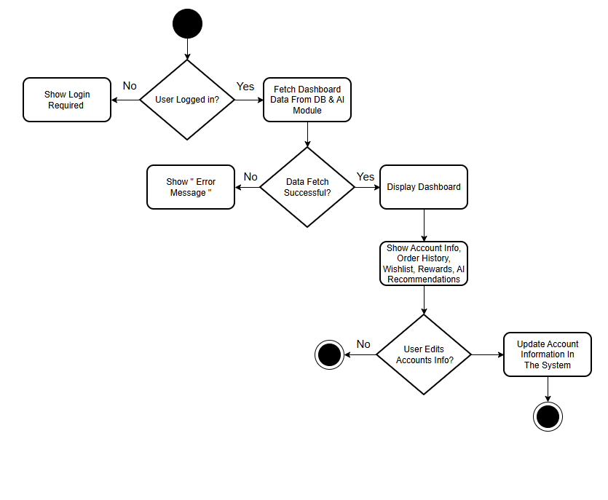

  - Use Case 7: AI-Powered Product Recommendations

ID | UC007
Name | AI-Powered Product Recommendations
Description | This use case Displays personalized product suggestions based on user behavior and history.
Requirement(s) | FR009
Actor(s) | Customer
Precondition | User must be logged in and have browsing/purchase history.
Postcondition | Recommended products are displayed on homepage, dashboard, or product pages.
Basic Flow | Basic Flow  - System collects user behavior (views, purchases, cart items).  - AI module generates relevant product suggestions.  - System displays recommended products to the user.  Alternative Flow:  - User clicks on a recommended product to view details.  Exceptions:  - AI module fails or insufficient data available

UML Activity Diagram:

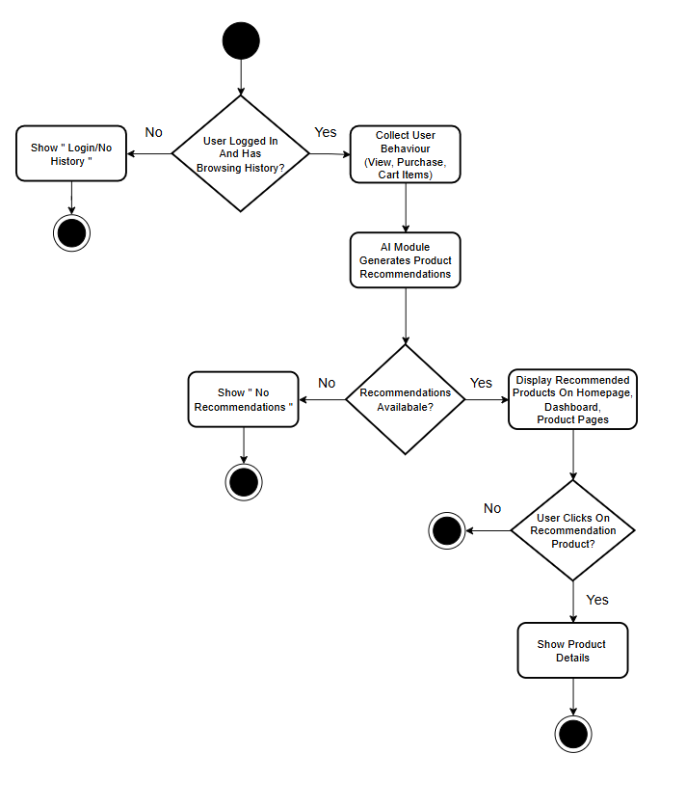
  - Use Case 8: AI-Powered Chatbot Assistance

ID | UC008
Name | AI-Powered Chatbot Assistance
Description | Provides real-time support, guidance, and personalized help to users.
Requirement(s) | FR010
Actor(s) | Customer, Vendor
Precondition | User is logged in and has access to chatbot interface.
Postcondition | User query is answered; relevant suggestions or steps provided.
Basic Flow | Basic Flow  - User opens chatbot interface.  - User types a query about product, order, or account.  - System processes query using AI chatbot.  - Chatbot responds with contextual answers, instructions, or product recommendations.  Alternative Flow:  - User escalates query to human support if AI cannot answer.  Exceptions:  - Chatbot service is unavailable.

UML Activity Diagram:

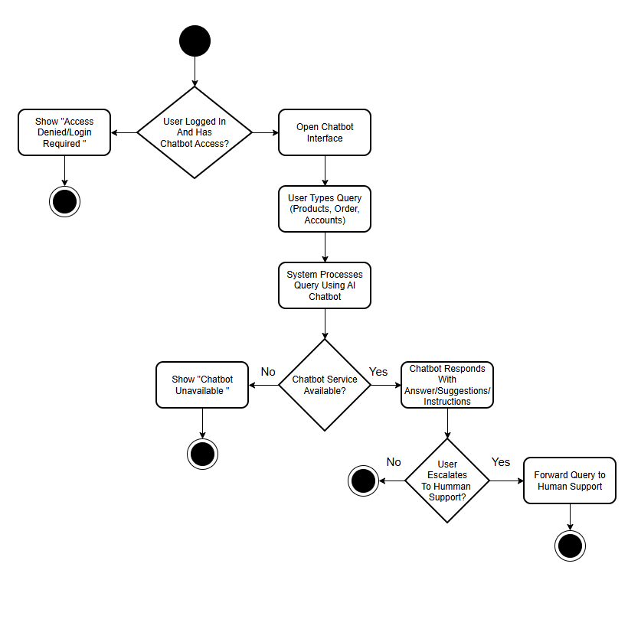

  - Use Case 9: Admin Panel

ID | UC009
Name | Admin Panel
Description | Allows the Administrator to manage system operations from a central interface.
Requirement(s) | FR013, FR014, FR015
Actor(s) | Administrator
Precondition | Admin must be logged in.
Postcondition | System updates settings, users, vendors, products, or orders based on admin actions.
Basic Flow | Basic Flow  - Admin logs into the Admin Panel.  - Dashboard displays system statistics.  - Admin manages users, vendors, products, orders, or settings.  - System saves changes and shows a success or error message.  Alternative Flow  - Admin updates only a specific section (e.g., vendors, products, orders).  Exceptions  - Unauthorized access.  - System error while updating data.

UML Activity Diagram:

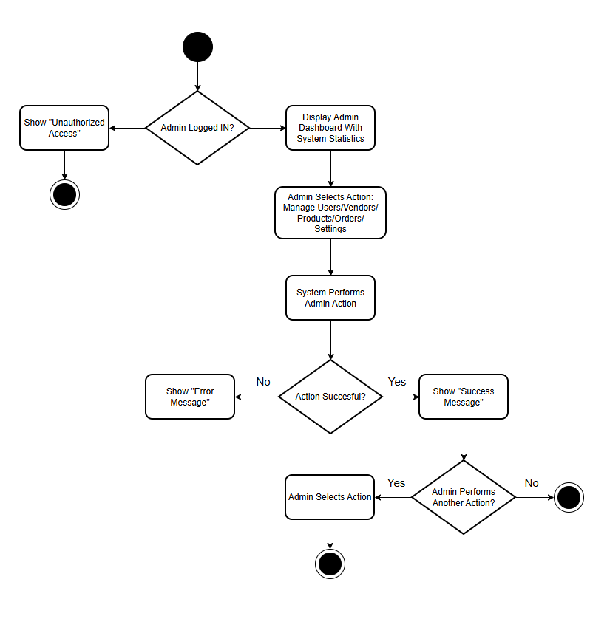

- References
- Z. Zhang, H. Chen, and M. Li, “AI-Based Product Recommendation for E-Commerce Using Machine Learning Techniques,” in Proceedings of the IEEE International Conference on Big Data Computing, 2020, pp. 45–52.
- A. R. Al-Akkad, “A Modular Architecture for Scalable Multi-Vendor E-Commerce Systems,” IEEE Access, vol. 8, pp. 14055–14067, 2020.
- A. Nuruzzaman and O. K. Hussain, “A Survey on Chatbot Implementation in Customer Service Industry through Deep Neural Networks,” in Proceedings of the IEEE International Conference on Machine Learning and Data Engineering (iCMLDE), 2021, pp. 47–54.
- M. N. Qureshi and S. Moon, “E-Commerce Adoption in Developing Countries: A Case of Pakistan,” in Proceedings of the IEEE International Conference on Emerging Markets (ICEM), 2021, pp. 112–118.
- N. Alalwan, H. B. Salameh, and M. Alshawabkeh, “Security Requirements for E-Commerce Systems,” in Proceedings of the IEEE International Conference on Computer and Information Sciences (ICCIS), 2020, pp. 1–6.
- T. Sharma and R. Singh, “AI-Driven Personalization in Online Retail Using Hybrid Recommendation Models,” in Proceedings of the IEEE International Conference on Data Science and Machine Learning, 2022, pp. 210–216.
- S. Khalid and U. Farooq, “Adoption of AI Chatbots in E-Commerce: Enhancing Customer Experience in Digital Marketplaces,” in Proceedings of the IEEE Global Conference on Computing, Power and Communication Technologies, 2022, pp. 98–104.
- P. Roques, UML in Practice: The Art of Modeling Software Systems, 2nd ed. Hoboken, NJ, USA: Wiley, 2021.
- Automatic, “WooCommerce REST API: Developer Guide,” WooCommerce Documentation, 2023.
[Online]. Available: https://woocommerce.com/document/woocommerce-rest-api/
- IEEE Computer Society, IEEE Standard for System Design—Description Practices, IEEE Std 1016-2020, 2020.

